**VIP BAGS**

|  |  |  |
| --- | --- | --- |
| Supervisor : | kulsom. | |
| Batch : | 2301C | |
| Group : | VIP BAGS | |
| Serial No. | Enrollment No. | Student Name. |
| 1. | 1447796 | Ameet kumar Dhera. |
| 2. | 1447483 | Hussain Bawani. |

**Acknowledgement**

*The first, we would like to express my special thanks of gratitude to my teacher MISS KULSOOM who helped a lot in finalizing this project within the limited time frame, valuable counseling and assistance for the accomplishment of this project.*

*Secondly, we would also like to thanks the e-project team at Aptech Head Office, who gave as the opportunity to do this interesting and wonderful project about VIP BAGS*

*Thirdly, we also thank the e-project team for giving this task to us. Following are the benefits of this Project:*

* *Re-enforcement of skills happens in the experimental learning process.*
* *A mentor, ensuring that we do not get drifted, constantly guide us.*
* *It gives us a lot of confidence to face an interview as we have worked on a project. We can explain virtually everything on the subject we have learnt.*

*Problems Definition*

*BagBag is an online store for various types of Bags. They have collection of bags.*

*Now they want to revamp their website with all the products listed on the website.*

*Consumers should find it easy to view various products and decide upon purchasing*

*the right product to meet their requirements.*

*A website needs to be designed to display various bags available with the store.*

*Details of locations, feedback must be included.*

*Customer Requirement Specification (CRS)*

*Requirement Specification:*

*The Web site is to be created based on the following requirements.*

*1) The Home Page should be created making use of Sections with a suitable*

*logo, the header section can be added which will show images of various*

*Bags.*

*2) The site must contain the links to navigate through various types of Bags,*

*BackPacks etc.*

*3) Site should have different section for Men and Women and bags should be*

*placed accordingly.*

*4) Links of bags must be categorized like (Bags, Sling Bags, BackPacks etc.)*

*5) Specification and Pricing of Bags should be added along with the images.*

*6) Website should provide section for various brands offered in the store.*

*7) Gallery section should be added for viewing different images.*

*8) Feedback must be allowed to enter by the viewer*

*9) Site map, Gallery, about us, Queries link, Contact us link must be added.*

*10) The complete description must be allowed to get download as pdf or doc file.*

*11) The advertise section with various facilities provided should be mentioned.*

*Screen shoot of e.project*

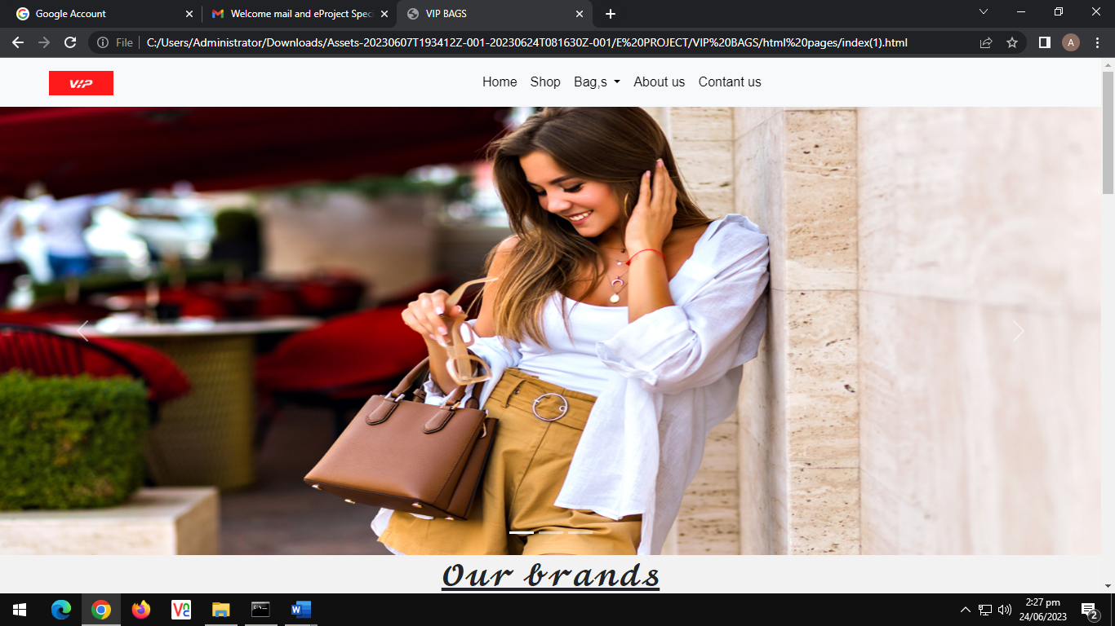

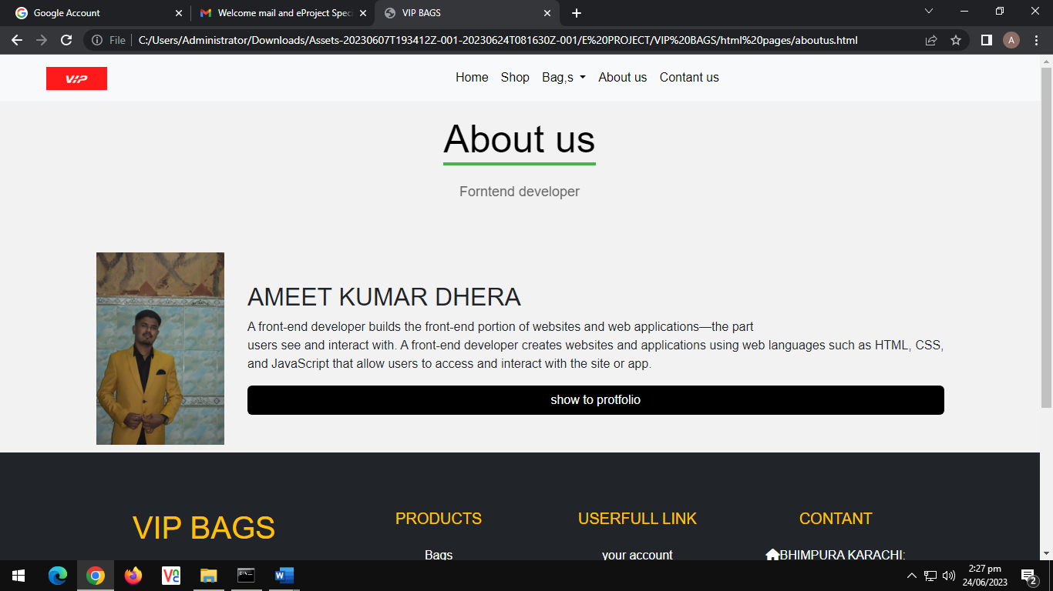

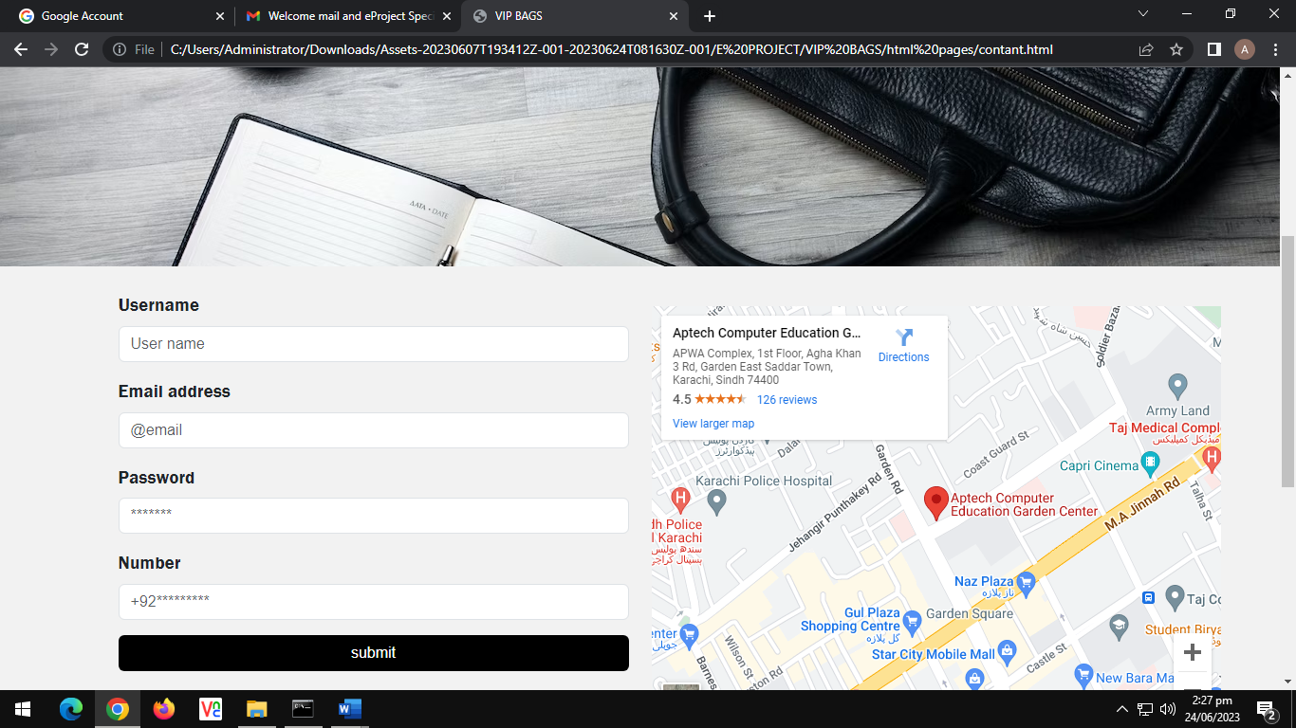

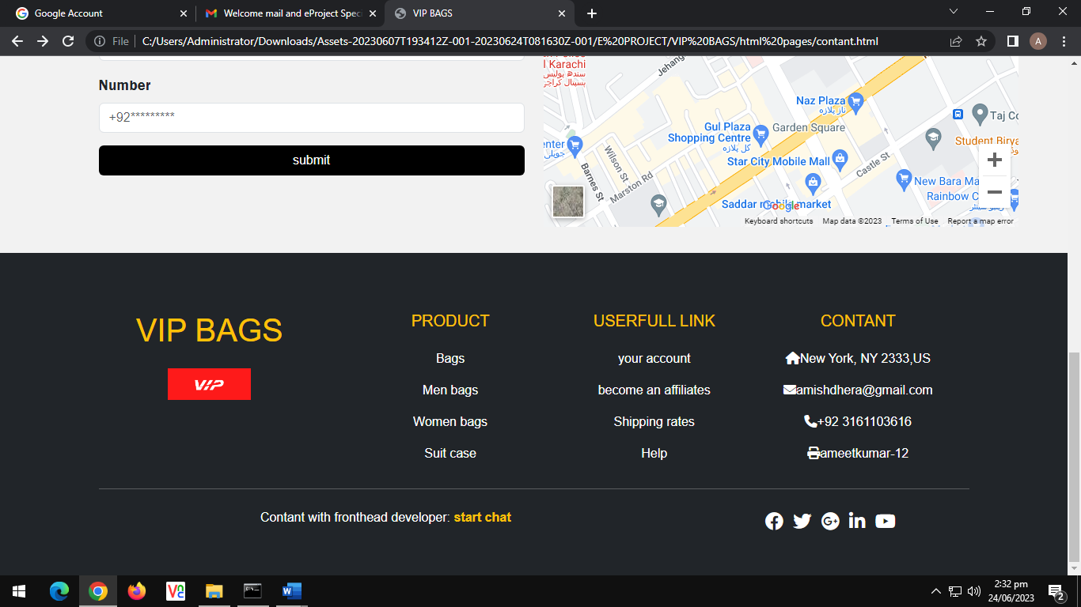

*Scope Of The Work (Briefly)*

*The name of the project is VIP BAGS the software provides the customer various facilities .in this project we can easily maintain VIP BAGS sales details.*

*It’s gives complete information of vip bags it’s name, price, and category etc. we can see the vip bags details before purchasing the particular bags and view for our requirements satisfying item detail.*

*Vip bags automation system provides ability to view any bags of different category available in the shop. Admin can perform login by entering Username and Password and register to purchasing .Users allotted to him and can view the feedback submitted bye Users. That means a she which has the system which provides the facility to the customer of the shop to purchase the bags from the shop without any difficulty and complexity.*

*For example any customer wants to purchase any bags from the shop than first customer has to login in the website and then just choose the category of the bags than he/she can see the more then one type of bags there and then he/she can choose the specific bags from there.*

***Sitemap English***

***TASK SHEET***

|  |  |  |  |  |  |  |
| --- | --- | --- | --- | --- | --- | --- |
| Project Ref.No:  Ep/Advertisement  Portal Management  System /01 | | ProjectTitle | Date Of preparation Of Activity Plan | | | |
| No. | ***Task*** | **V**  **I**  **P**  **B**  **A**  **G**  **S** | ***Actual***  ***Start Date*** | ***Actual Days*** | ***Team-Mate***  ***Name*** | ***Status*** |
| 01. | ***Home page*** | 23  -  M  A  Y  -  2  0  2  3 | 3  0  -  D  A  Y  S  - | All |  |
| 02. | ***Shop page*** | AMEET  KUMAR  DHERA |  |
| 03. | ***About page*** | AMEET  KUMAR  DHERA |  |
| 04. | ***Contact page*** | All |  |
| 05. | ***Login/ Register page*** | AMEET  KUMAR  DHERA |  |
| 06. | ***Documentation*** | AMEET  KUMAR  DHERA |  |